Machine Learning Assignment 1

Q1: What were the most important things you learned from exploring the dataset? Refer to relevant statistics, missing values, distributions, unusual observations and visualizations.
The most important things we learned from exploring the were:
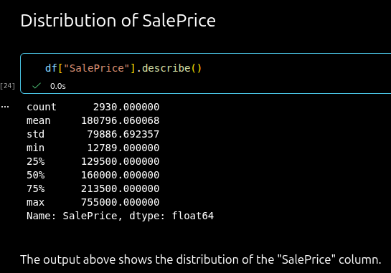
the distribution of SalePrice,
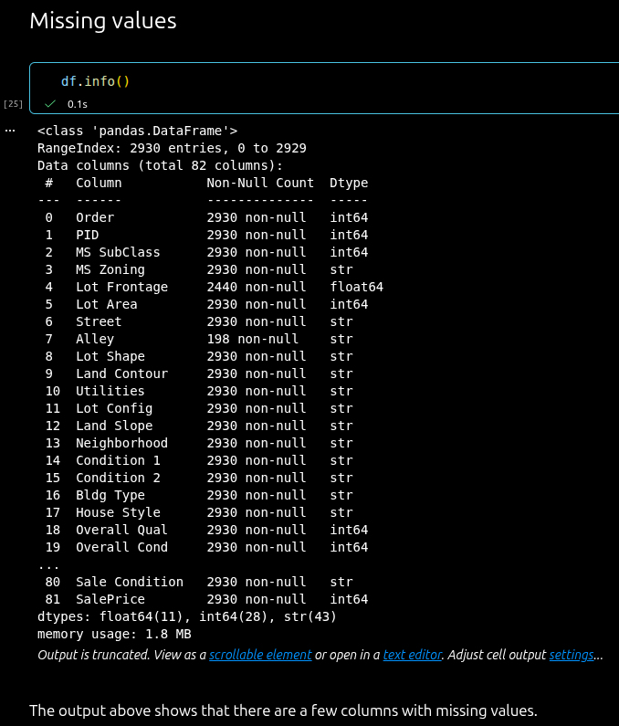
missing values, and
some useful relationships for predicting the house price.

Q2: Which features appeared to be useful for predicting house prices? What evidence led you to this conclusion? Refer to relevant visualizations, descriptive statistics, correlations or your understanding of the variables.
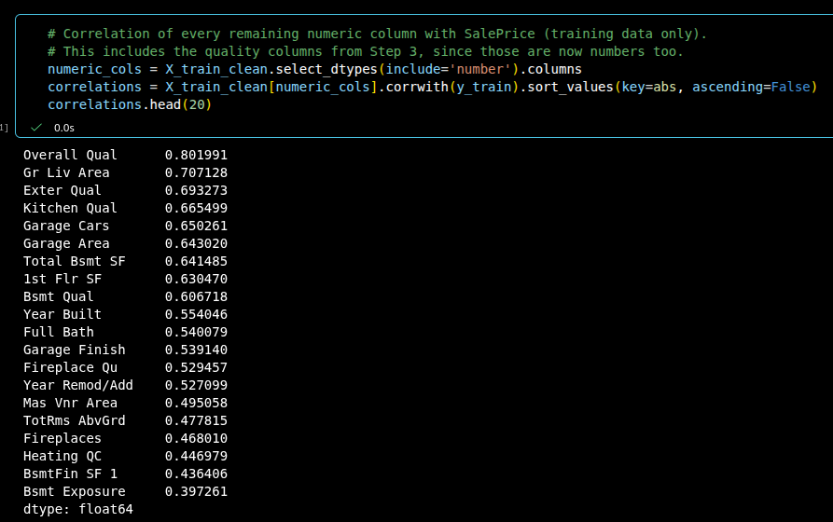
The features that we though appeared useful were picked from this analysis, where we found the correlation with “SalePrice”. The three features with the highest correlation were “Overall Qual”, “Gr Liv Area”, and “Exter Qual”.

Q3: How did you create the training and test sets? Why should the test set be kept separate during model development, and how does this help provide an unbiased evaluation on unseen data?
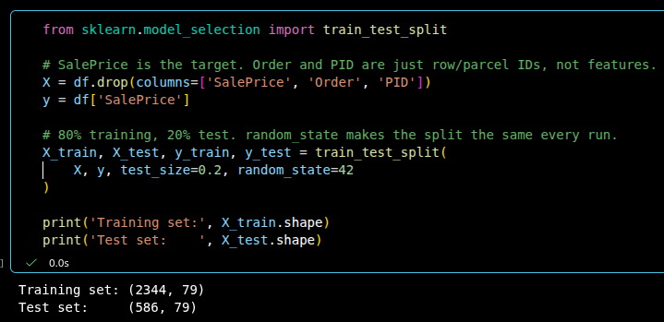
We used the train_test_split method from scikit-learn to create the training and test sets using a 80/20 split, where the majority of the data is in the training set. The test set should be kept separate during model development because it is our only way to check how the models perform on houses they have never seen.

Q4: How did you handle missing values and categorical variables? Explain your main preprocessing decisions, including scaling or transformations if used. Why should preprocessing be learned from the training data and then applied to the test data?

